 | Course Name: Advanced Web Technology | EXPERIMENT NO. 1
 | Course Code: 20CP314P Faculty: Komal Singh | Branch: CSE | Semester: VI
Submitted by: Harsh Shah Roll no: 21BCP359

Objective: Building a Simple Web Server in Node.js
Experiment: Implement the NodeJS Programs.
  - Write Node JS programs for following modules:
- http
const http = require('http');
const server = http.createServer((req, res) => { res.writeHead(200, { 'Content-Type': 'text/plain' }); res.end('Hello World!\n');
});
server.listen(3000, 'localhost', () => { console.log('Server running at http://localhost:3000/');
});
Output:-
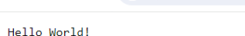

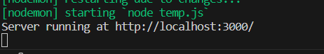
- filesystem
const fs = require('fs');
const fileName = 'example.txt';
const fileContent = 'This is a sample text file.'; fs.writeFile(fileName, fileContent, (err) => {
if (err) throw err;
console.log(`${fileName} has been created.`);
});
fs.readFile(fileName, 'utf8', (err, data) => { if (err) throw err;
console.log(`Contents of ${fileName}:`); console.log(data);
});
Output:-
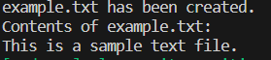
- URL
const url = require('url'); const urlString =
'https://www.example.com/path/to/resource?query1=value1&query2=value2'; const parsedUrl = url.parse(urlString, true);
console.log('Parsed URL:');
console.log(parsedUrl);
Output:-
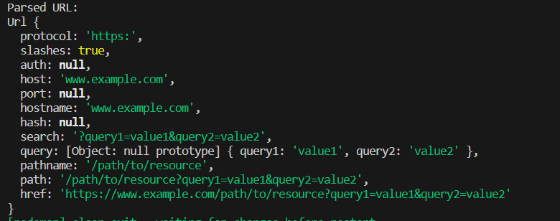
- Event
const EventEmitter = require('events'); class MyEmitter extends EventEmitter {} const myEmitter = new MyEmitter(); myEmitter.on('event', () => {
console.log('Event emitted!');});
myEmitter.emit('event');

Output:-
